ASSIGNMENT

NM ID:A0B3D28147B66CCB0894F54DB0D0E9D5

NAME:ASKAR M

1.Website using wordpress

Link: <https://astravels15.wordpress.com>

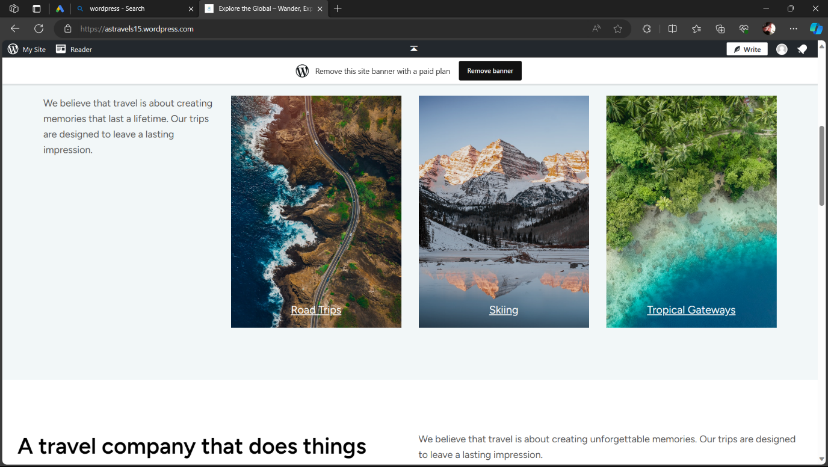

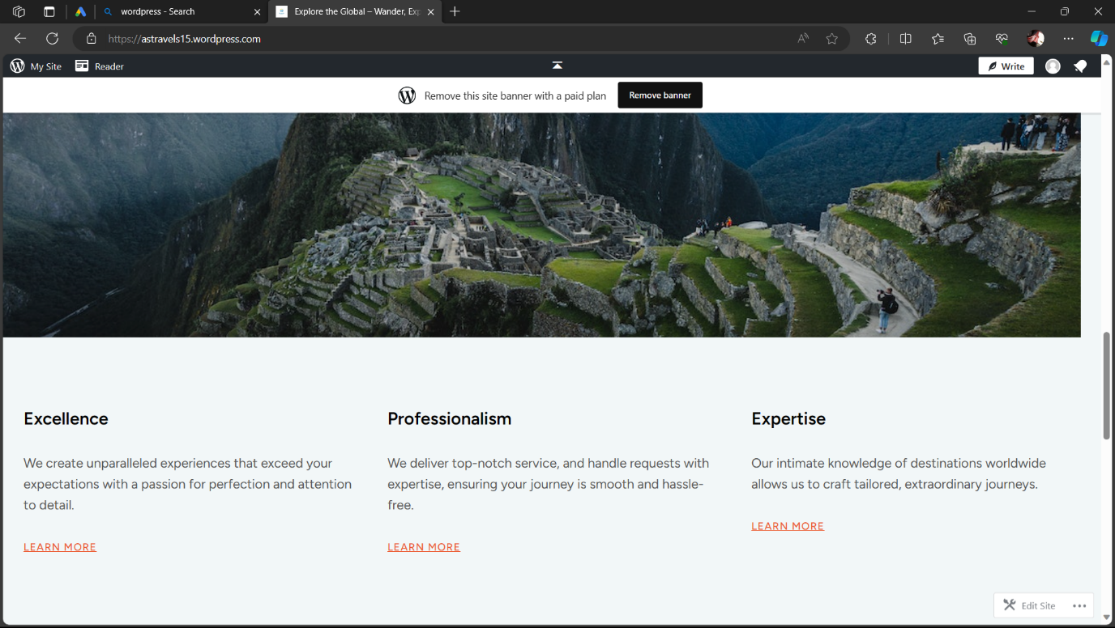

2.Create a new facebook business page and post one social media poster for your brand.

Link: [Facebook](https://www.facebook.com/profile.php?id=61552323327740)

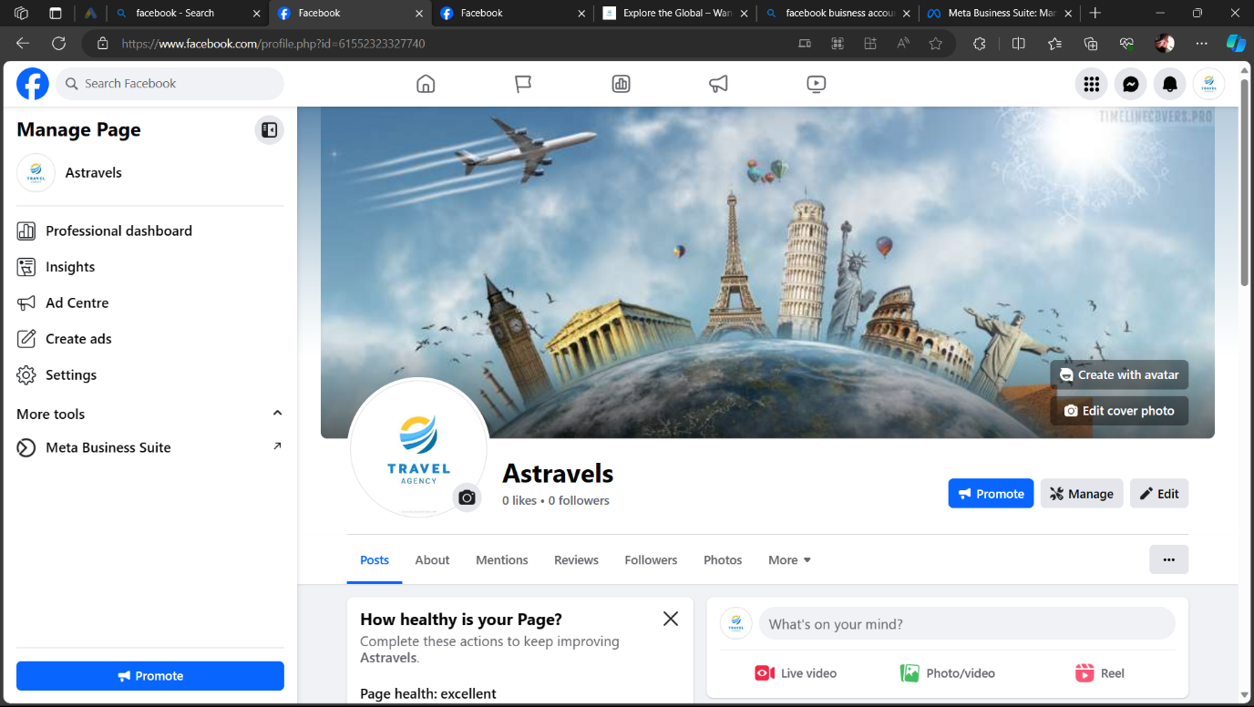

3.Create and design a social media advertisement poster using canva

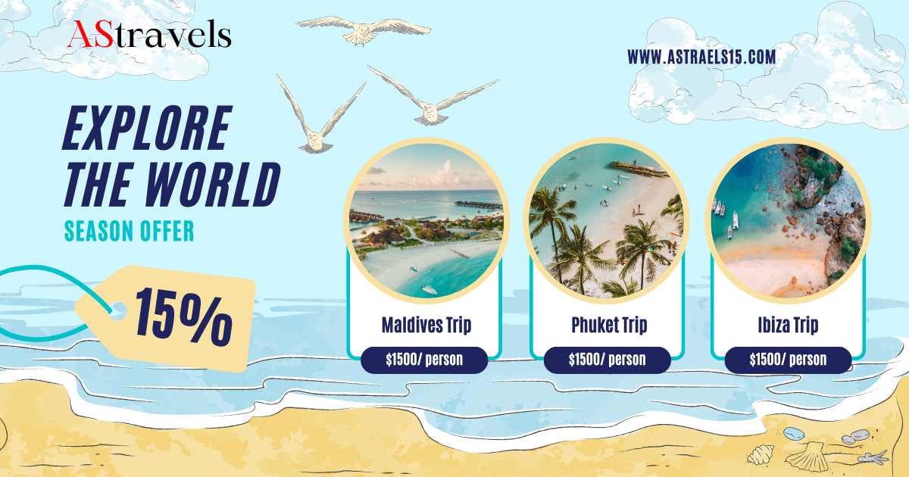

4.Create email newsletter design using mailchimp or canva tool.

